7.3: In Eq. (7.7), taking 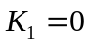 (as in Example 6.4) and 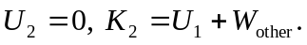 Friction does negative work 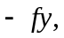 so 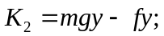 solving for the speed 